附件2：（1）中文摘要模板参考(注：每份摘要务必控制在一个页面以内)
（2）英文摘要模板参考(注：每份摘要务必控制在一个页面以内)

南极磷虾虾糜和蛋白的制备及功能特性研究
朱俊向，许 丹，陈 瑜，张小军，丁国芳
（浙江省海洋水产研究所，浙江海洋大学海洋与渔业研究所，浙江 舟山 316021）
联系邮箱：zhujunxiang89@zjou.edu.cn；联系电话：0580-2299872
【文字摘要】
目的: 优化等电点沉淀法和碱溶酸沉法分别制备南极磷虾虾糜和蛋白的工艺，并评价两种南极磷虾蛋白原料的功能特性。
方法:
（1）南极磷虾虾糜制备：称取4 g南极磷虾肉，加入不同体积的去离子水（4°C）匀浆。随后，用2 M磷酸调为不同pH，静置不同时间，离心后收集沉淀，通过凯氏定氮法计算其蛋白质回收率。
（2）南极磷虾蛋白制备：称取4 g南极磷虾肉，加入不同体积的去离子水（4°C）匀浆。随后，用2 M氢氧化钠调为不同pH，静置0.5 h后，离心得到上清液，整个提取过程重复若干次数。最后，将上清液用2 M磷酸调pH为4.5，静置1.0 h后，离心收集沉淀，通过凯氏定氮法计算其蛋白质回收率。
（3）虾糜和蛋白制备工艺优化：上述工艺涉及参数，如液料比、pH、静置时间和提取次数等采用响应面Box-Benhnken设计进行优化。
（3）功能特性研究：溶解性、持水性、持油性、乳化性、稳定性、起泡性和泡沫稳定性。
结果: 确定的南极磷虾虾糜制备最优工艺为液料比3.2:1 mL/g、酸沉pH 4.4、静置时间1 h；南极磷虾蛋白提取最优工艺为液料比3.2:1 mL/g、碱溶pH 11.4、提取3次。两种工艺的蛋白质回收率分别为70.05%和63.21%。功能特性研究表明，南极磷虾虾糜和蛋白的持水性和持油性优于虾肉，然而，乳化性和起泡性与虾肉相差不大。
结论: 本研究建立了南极磷虾虾糜和蛋白的最优制备工艺，两种工艺条件下的蛋白质回收率与模型预测值接近。功能特性研究表明，南极磷虾蛋白的溶解性、持水性、持油性、乳化稳定性和起泡性最好，而乳化性和泡沫稳定性，虾肉、虾糜和蛋白三者之间无显著差异。
【关键词】南极磷虾；虾糜；蛋白提取；功能特性
【图片摘要】
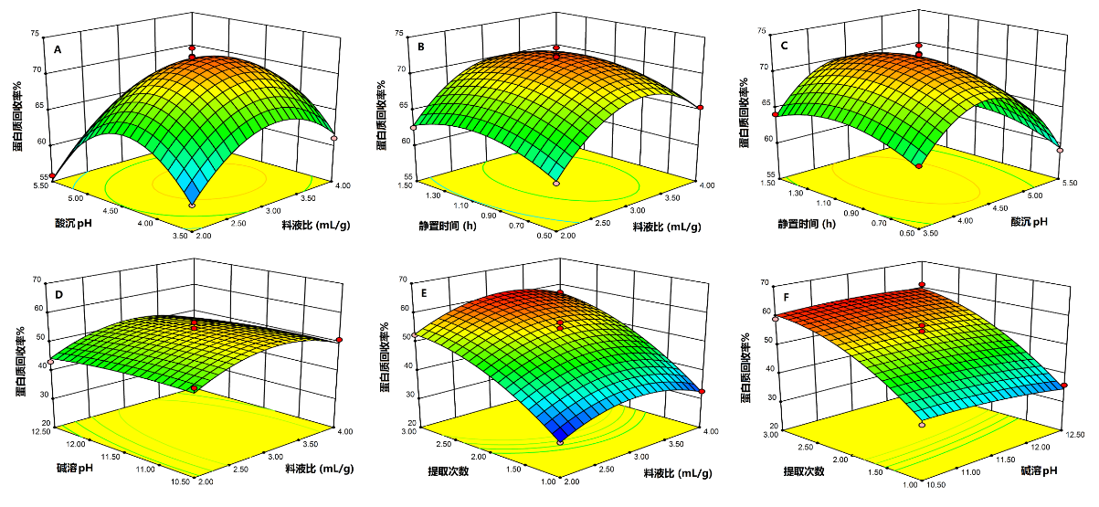
不同工艺参数影响南极磷虾虾糜（A-C）和蛋白（D-F）蛋白质回收率的响应面图
Study on the Metabolism of Fibrinolytic Active Compound FGFC1 in Rat Liver Microsomes and in vivo
Zibin Ma¹，Ruihua Guo¹，Bin Bao¹，Wenhui Wu^{1※}
（¹College of food Science and Technology, Shanghai Ocean University, Shanghai 201306）
（E-mail : zibinma@163.com ; Tel: 15601810880）
[Abstract]
Objective: We investigated a novel marine fibrinolytic compound for use in thrombolytic therapy. Pharmacokinetics and the tissue distribution of this novel marine fibrinolytic compound, FGFC1 (fungi fibrinolytic compound 1), were investigated in Wistar rats after intravenous (IV) bolus administration of two concentrations (10 and 20 mg/kg).
Methods: Plasma FGFC1 and tissue extracts were measured using HPLC with UV detection. FGFC1 was detected using a C18 column with a gradient eluted mobile phase of acetonitrile-water (0.1% trifluoroacetic acid), 1.0 mL/min. Chromatograms were monitored at 265 nm (column temperature: 40℃).
Results: Pharmacokinetic data indicate that FGFC1 fitted well to a two-compartment model. Elimination half-lives (t1/2) of FGFC1 were 21.51±2.17 and 23.22±2.11 min for 10 and 20 mg/kg, respectively. AUC0-t were 412.19±19.09, 899.09±35.86 μg/ml×min, systemic clearance (CL) was 0.023±0.002, 0.022±0.002 ((mg/kg)/(μg/ml)/min) and the mean residence time (MRT) was 10.15±0.97, 9.65±1.40 min at 10 and 20 mg/kg, respectively. No significant differences were observed in the systemic clearance and mean residence time at the tested doses, suggesting linear pharmacokinetics in rats. Tissue distribution data reveal that FGFC1 distributed rapidly in most tissues except the brain and that the highest concentration of the drug was in the liver. In the small intestine, FGFC1 initially increased and then declined, but remained comparatively high 60 min after administration, suggesting that enterohepatic circulation may exist.
Conclusion: FGFC1 has good pharmacokinetics and tissue distribution in Wistar rats.
[Key words] FGFC1; pharmacokinetics; Tissue distribution; HPLC
[Graphical Abstract]
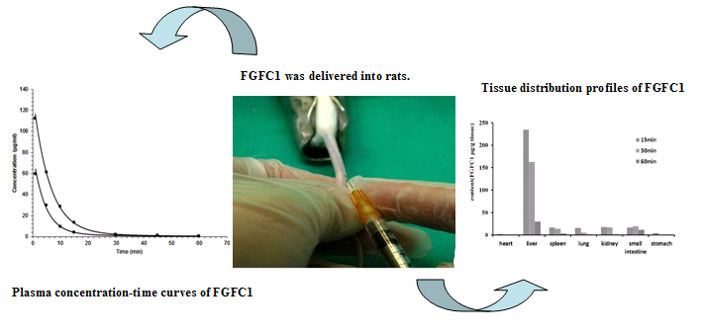
FGFC1 pharmacokinetics and tissue distribution in Wistar rats

